DB Term Team Project

Ricardo Longo, John Fisher, Winsor Tse

Database Systems (CISC-3500-R01)

Fordham University

**ER diagram**

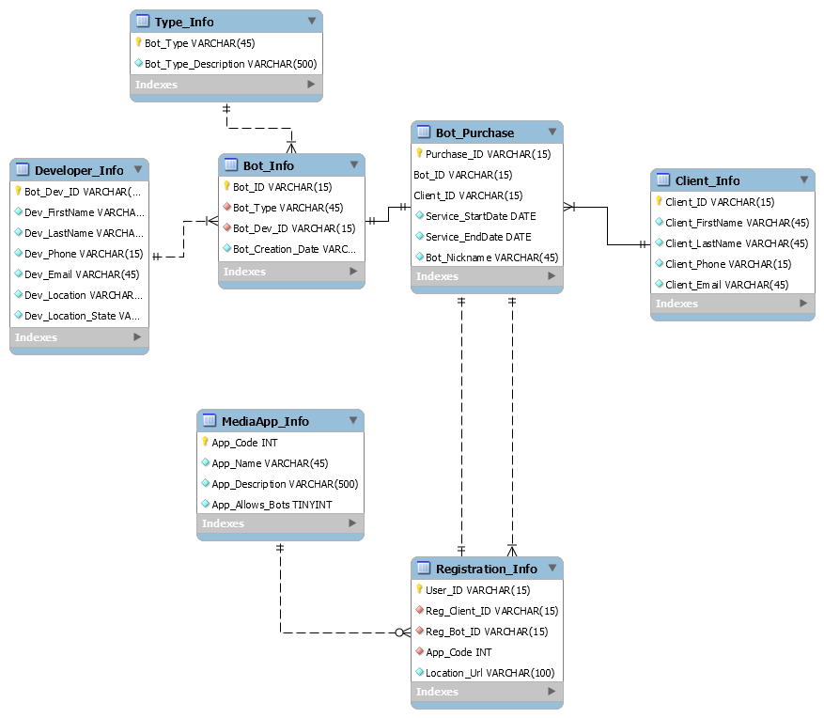

**Tables With Data**

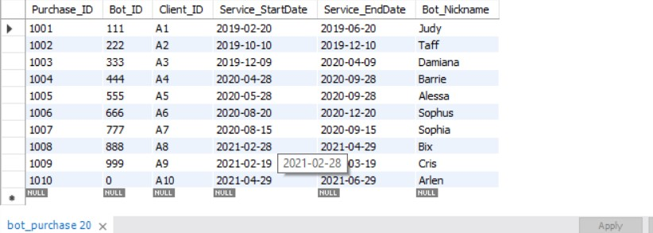

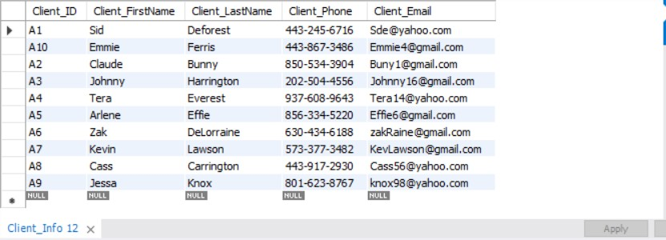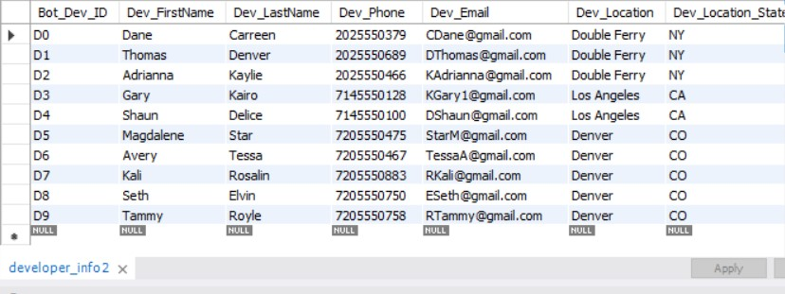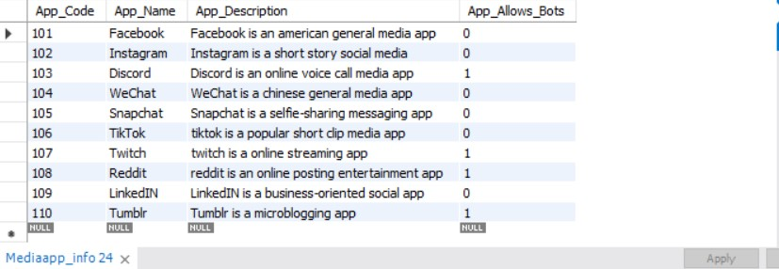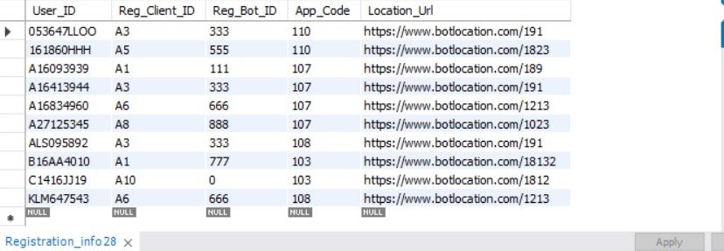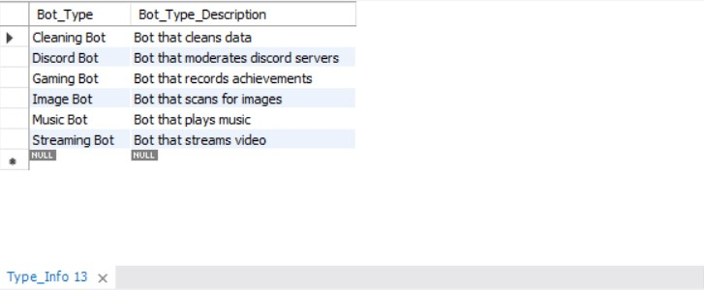

**Results from Queries**

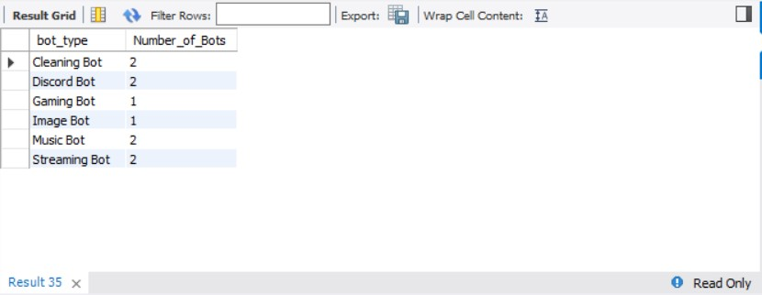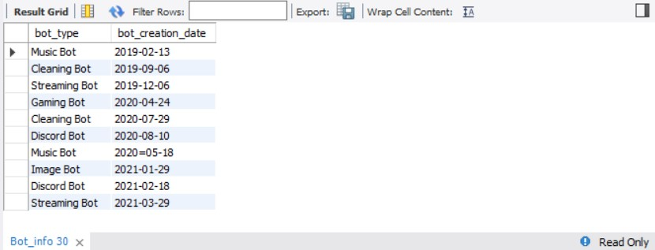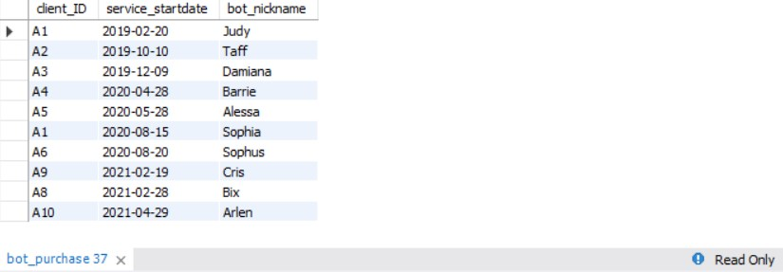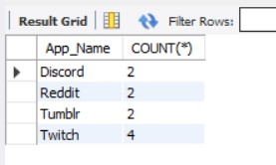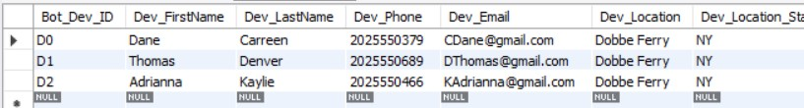

**Description About the Project**

Our project focuses primarily on the creation of the database for WITS INC. In the database, we create multiple tables, like Bot_Info, which stores the information of individual bots. Bot_ID is used to recognize each bot in the database. Bot_ID is the primary key of Bot_Info. Bot_ID appears as a foreign key in Bot_Purchase and Registration_Info. Bot_ID is of VARCHAR(15); most columns in the database are of VARCHAR as they allow for the use of letters and more extensive entries on the database than INT or other types might let in the database. Developer_Info stores the information of the creator of each bot, including some of their basic information and their location. Primary key Bot_Dev_ID connects the link to Bot_Info with Developer_info. Type_Info indicates how each bot types work and is linked to Bot_Info by Bot_Type. Unlike other tables, Bot_Purchase has the primary Purchase_ID, which is not foreign to any other table. Instead, Client_ID is used to link Bot_Purchases with Client_Info and Registration_Info. The use of Client_ID helps to connect the tables more fluently as the Client_ID is necessary to identify the owner of the bot and account, unlike Purchase_ID, which is used only to confirm that the purchase happens. Bot_ID is used to link Bot_Purchase and Registration_Info as the ID is needed to identify which bot is being bought and registered. Registration_Info is used to record when a bot is used in a Media App. It is linked to MediaApp_Info with its primary key App_Code, which we made of type INT. We made App_Code of type Int simply because the number of Social media that people use is limited (the same few media are used, rarely a new social media emerges). In this case, we found INT to be more simple for people to identify, similarly as might be a code that the user might use, so simplicity for the user is better. This is how our database works and some of the few design choices we took different than other databases might have done. ***UwU***